Amity Creek Supplemental Data
Duluth WRAPS
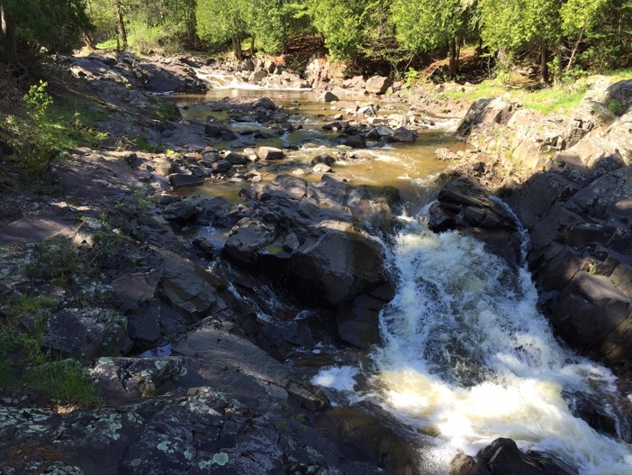
Prepared by South St. Louis Soil and Water Conservation District (SWCD)
2016/2017

Amity Creek Watershed

Recommendations

Road Crossing Replacement, Removal, or Repair
These road crossings are the highest priority crossings recommended for replacement, removal, or repair in the Amity Creek watershed.
Street Name
Mainstem—Woodland Avenue
East Amity—West Tischer Road
Mainstem--Seven Bridges Road, 3rd bridge
Mainstem—Nelson Road
Mainstem—Jean Duluth Road
Mainstem—Thomas Road
East Amity—Arnold Road

Additional Data Sources

USGS
The United States Geological Survey (USGS) assessed Duluth’s streams in 2006 in an attempt to characterize and classify them. Following an estimated 500 year flood in June of 2012, it was decided that the 2006 sites would be reassessed to observe the impact the flood had on these reaches. This data was also used to determine the sensitivity to disturbance for reaches within all the major watersheds in Duluth. The downstream section of Amity Creek, in the Seven Bridges Road area, is identified as low sensitivity. The mid sections of both the main stem and East Amity are high to moderate, and high sensitivity. The most upstream section of East Amity has high sensitivity, while the most upstream section of the main stem has moderate to low sensitivity. Many intensive surveys and rapid assessments were completed by the USGS on Amity Creek.
USGS site Name | Assessment Type | Location
11 | Intensive | Occidental Road, Lester Park
12 | Rapid | Occidental Road, Amity Creek Park, #1
13 | Rapid | Occidental Road, Amity Creek Park, #2
14 | Rapid | Occidental Road, Amity Creek Park, #3
15 | Rapid | Occidental Road, Amity Creek Park, #4
16 | Rapid | Occidental Road, Amity Creek Park, #5
17 | Rapid | Occidental Road, Amity Creek Park, #6
18 | Rapid | Skyline Road

Minnesota Department of Natural Resources Fisheries Management Plan
Amity Creek is a designated trout stream. Both steelhead/rainbow trout and brook trout are present in the stream the steelhead migrate into the stream from Lake Superior and can only go upstream as far as the most downstream bedrock waterfall, barrier. Steelhead fry are stocked annually off of Seven Bridges Road. Brook trout are located in the upper watershed. Currently no brook trout stocking is occurring. In the past brown trout were also stocked in Amity Creek. This occurred from 1955 to 1971. The DNR fisheries management plan states the goals of providing steelhead nursery habitat, maintaining current brook trout populations, mitigating erosion, and reestablishing vegetation as goals for the watershed.

Watershed Results

Connectivity

Stream Road Crossings
Twenty nine road crossings exist within the Amity Creek watershed (Figure 1). 45 percent of these crossings are identified as barriers based on phase 1 of the Stream Crossing Prioritization Matrix. And 24 percent of the barriers are of high priority for replacement, removal, or repair. The Amity Creek watershed has the lowest number of road crossings per stream mile (1.1) and lowest number of road crossings acting as barriers per stream mile (0.5). Two crossings in Amity are included in the five highest priority stream road crossings for replacement, removal, or repair within the six study watersheds in Duluth (Keene, Merritt, Miller, Chester, Tischer, and Amity). These crossings include the Woodland Avenue crossing on the mainstem and the West Tischer Road crossing on the East Branch. The Woodland Avenue crossing is very narrow (half the width of the stream channel). This narrow width causes high velocities in the culvert during high flows. Fish cannot swim through these high velocities and the crossing is a barrier. The five highest priority road crossings for replacement, removal, or repair within the Amity Creek watershed are spread throughout the watershed and are located on both the mainstem and East Amity (Table 1).

Table 1. The highest priority road crossings within the Amity Creek watershed.
Street Name | Score
Mainstem—Woodland Avenue | 160
East Amity—West Tischer Road | 165
Mainstem--Seven Bridges Road, 3rd bridge | 180
Mainstem—Nelson Road | 240
Mainstem—Jean Duluth Road | 240
Mainstem—Thomas Road | 240
East Amity—Arnold Road | 240

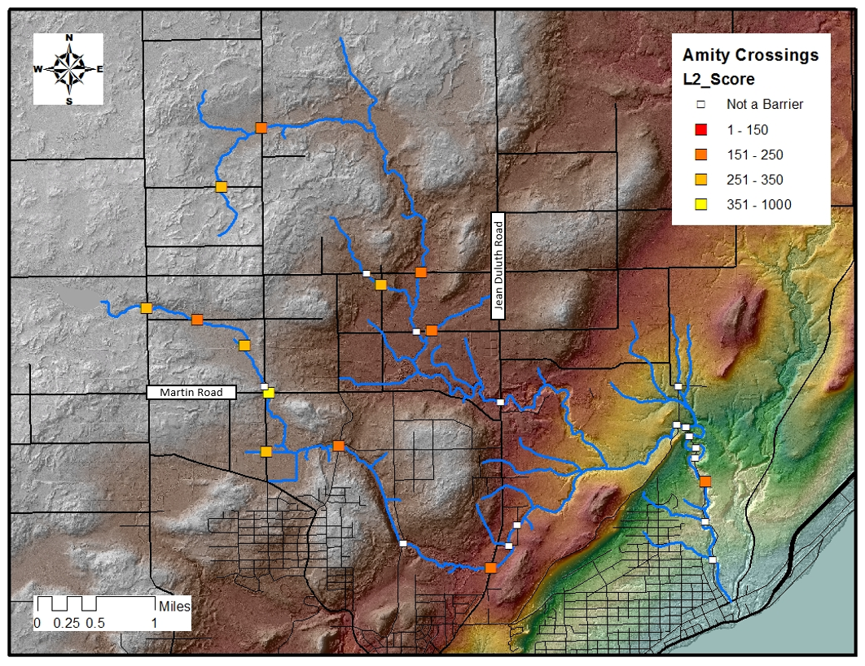
Figure 1. Road crossings within the Amity Creek watershed.

